Ex.No:8
Date:

Testing of Requirements
Aim
The aim of this experiment is to study how efficiently a program can be tested by analyzing its control flow. It mainly focuses on calculating Cyclomatic Complexity and identifying independent execution paths, which helps in deciding the minimum number of test cases needed for complete testing.
Problem Description
In software testing, it is important to verify that every logical path in a program is executed at least once. In this experiment, the program is represented using a Control Flow Graph (CFG), where nodes represent statements and edges represent the flow of control. By analyzing this graph, the complexity of the program can be understood and all execution paths can be tested properly.
.Given Conditions
The given program includes basic structures such as sequential statements, decision-making conditions, and loops. It has a single entry point and a single exit point. Each part of the program is represented as a node, and the connections between them are represented as edges. The important parameters required are:
Number of Nodes (N)
Number of Edges (E)
Number of Decision Nodes (P)
These values are used to calculate complexity and ensure proper test coverage.
Methodologies
First, the program is broken down into smaller logical parts. Each part is represented as a node in the control flow graph. Then, connections between nodes are drawn based on the sequence of execution. After constructing the graph, the number of nodes and edges is counted. Using these values, Cyclomatic Complexity is calculated. Finally, independent paths are identified and suitable test cases are prepared so that every path is executed at least once.
About the Node Diagram
The node diagram, also called the Control Flow Graph, shows how a program executes step by step. Each node represents a statement or a block of code, and arrows indicate the direction of execution. Decision statements and loops create branches in the graph. This diagram helps in understanding the interaction between different parts of the program and in identifying all possible execution paths.
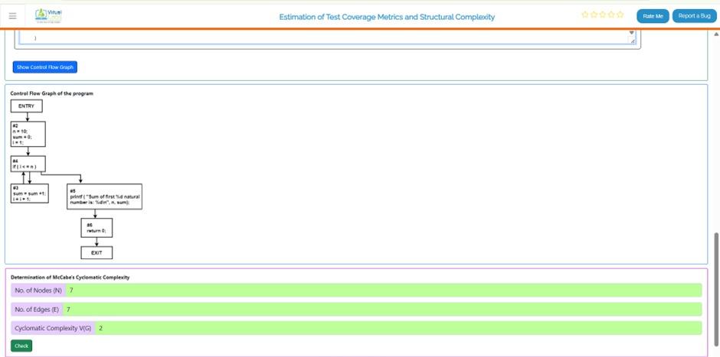
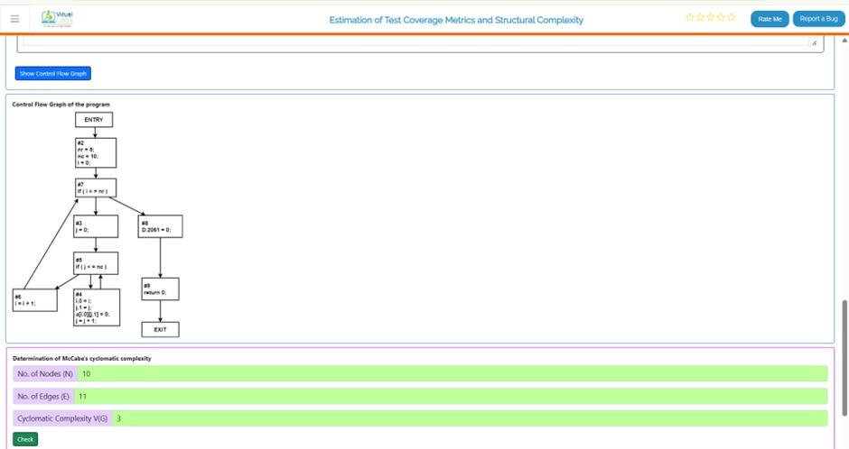
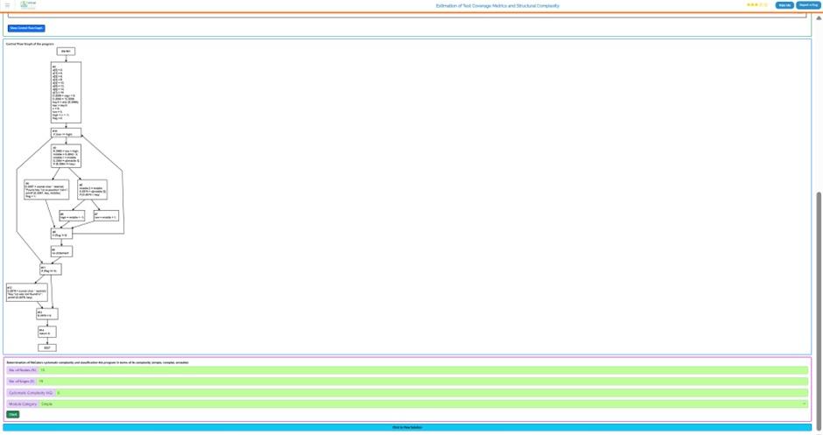

Working of Nodes
In a control flow graph, nodes represent program statements and show how execution flows from one part to another. The complexity of this graph is measured using Cyclomatic Complexity. The formula used is:
V(G) = E − N + 2
Where:
V(G) = Cyclomatic Complexity
E = Number of edges
N = Number of nodes
Another formula is:
V(G) = P + 1
Where:
P = Number of decision (predicate) nodes
These formulas help in finding the number of independent paths in the program. Each path represents a unique execution flow that must be tested. Nodes together form these paths and ensure all conditions and loops are properly checked
Result
After drawing the control flow graph, the values of nodes and edges are obtained. For example, if N = 10 and E = 11, then:
V(G) = 11 − 10 + 2 = 3
This means there are 3 independent paths in the program. So, at least 3 test cases are needed for complete path coverage. The result shows that the program has a moderate level of complexity.
Conclusion
This experiment explains the importance of Control Flow Graphs and Cyclomatic Complexity in software testing. By analyzing the structure of a program, all independent paths can be identified and effective test cases can be designed. This improves software quality and reduces the chances of errors remaining undetected.

